ASSINMENT-1
AMAZON SALES ANALYSIS AND INTERACTIVE BUSINESS INTELLIGENCE DASHBOARD USING POWER BI
1. AIM
To design and implement an interactive Amazon Sales Analysis Dashboard using Microsoft Power BI by importing, cleaning, transforming, modeling, and analyzing transactional sales data, and by developing multiple analytical dashboard pages for revenue, products, categories, customers, orders, geography, and performance insights.

2. OBJECTIVES
- To understand the complete Business Intelligence workflow using Microsoft Power BI.
- To import Amazon sales data into Power BI.
- To inspect and improve the quality of the source data.
- To identify and remove duplicate records.
- To handle null and blank values.
- To assign appropriate data types to the dataset fields.
- To create calculated columns for time-based analysis.
- To create a Calendar table for date analysis.
- To establish relationships between the sales table and Calendar table.
- To create DAX measures for important business KPIs.
- To analyze total revenue, orders, customers, products, and categories.
- To create interactive sales trend visualizations.
- To perform product and category analysis.
- To perform customer and order analysis.
- To perform geographic analysis.
- To implement Top-10 product filtering based on revenue.
- To create interactive navigation between dashboard pages.
- To design a professional multi-page Power BI dashboard.

3. TOOLS / SOFTWARE REQUIRED
- Microsoft Power BI Desktop
- Amazon Sales Dataset
- Power Query Editor
- DAX – Data Analysis Expressions
- Microsoft Excel if the source data is provided in Excel format

4. DATASET USED
The project uses an Amazon Sales Dataset containing transactional sales information.
Important fields used during the analysis include:
- OrderDate
- OrderID
- OrderStatus
- CustomerID
- Category
- UnitPrice
- Quantity
- Revenue
A separate Calendar table was also created to support date-based analysis.

5. THEORY
5.1 Business Intelligence
Business Intelligence is the process of collecting, transforming, analyzing, and presenting data to generate meaningful information for business analysis and decision-making.
Power BI provides an integrated environment for:
Data → Transformation → Modeling → Analysis → Visualization → Insights

5.2 Power Query
Power Query is the data preparation component of Power BI.
It allows the user to:
- Import data
- Remove duplicates
- Handle null values
- Change data types
- Create calculated columns
- Filter records
- Transform data
- Prepare the final dataset for analysis

5.3 Data Modeling
Data modeling is the process of organizing data tables and relationships so that Power BI can perform reliable analysis.
In this project, the Amazon sales table acts as the main transactional data source, while the Calendar table provides structured date information.

5.4 DAX
DAX is the calculation language used in Power BI.
It is used to create measures such as:
- Total Revenue
- Total Orders
- AOV
- Unique Customers
- Total Quantity
These measures dynamically respond to filters and slicers applied to the dashboard.

5.5 KPI
A Key Performance Indicator represents an important business metric.
The dashboard uses KPI cards to provide an immediate overview of sales performance.
Examples include:
- Total Revenue
- Total Orders
- Average Order Value
- Unique Customers

5.6 Interactive Dashboard
Unlike a static report, an interactive Power BI dashboard allows users to explore data dynamically through:
- Filters
- Slicers
- Cross-filtering
- Drill-down
- Top-N analysis
- Page navigation
- Interactive charts

6. PROCEDURE
PART A: OPEN POWER QUERY AND INSPECT THE DATA
Step 1: Open Power Query Editor
Launch Microsoft Power BI Desktop.
Open:
Home → Transform Data
Power Query Editor is used to inspect and prepare the Amazon sales dataset.
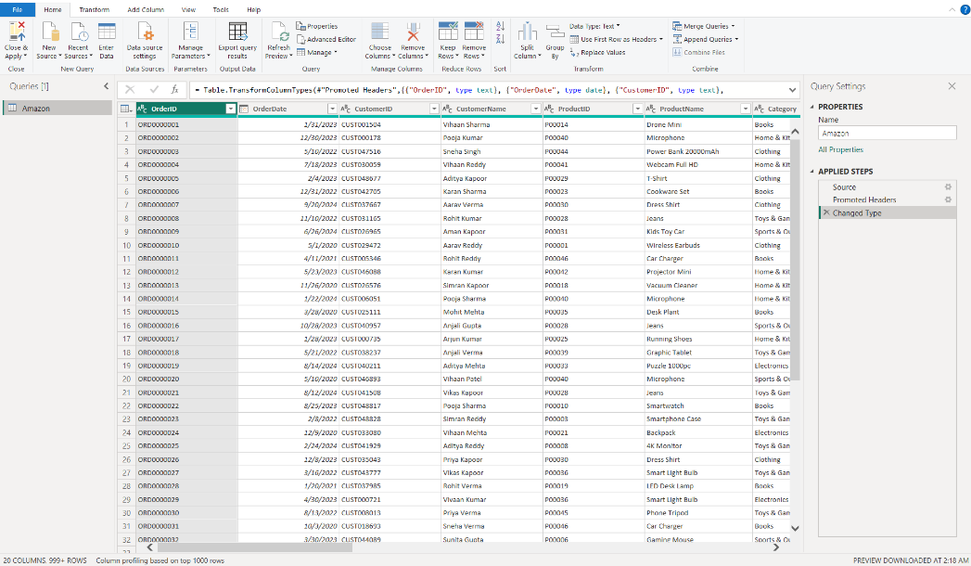
01_power_query_open.png
The screenshot shows the Power Query environment with the imported Amazon data.

PART B: DATA QUALITY AND CLEANING
Step 2: Inspect Data Quality
Examine the dataset for:
- Blank values
- Null values
- Duplicate records
- Incorrect values
- Inconsistent data
- Incorrect data types
The purpose of this step is to ensure that the dataset is suitable for further analysis.
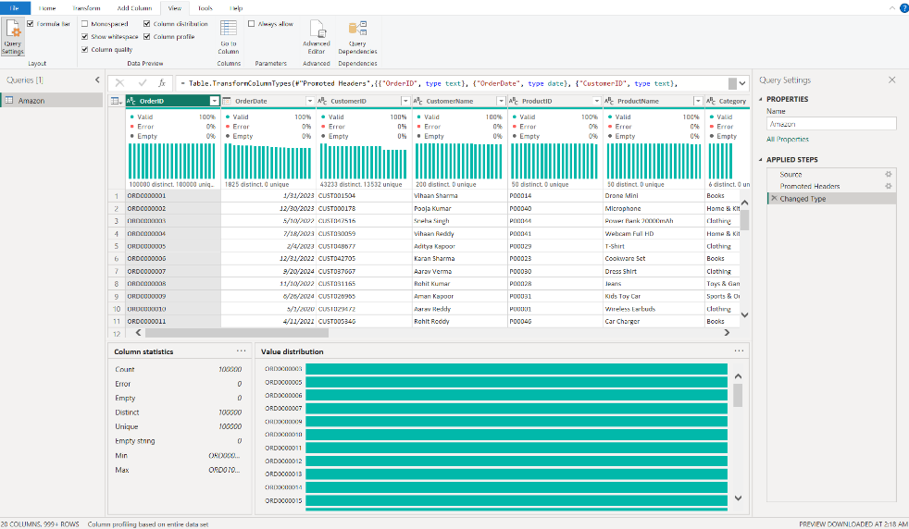
02_data_quality.png
Take the screenshot after inspecting the data quality.

Step 3: Remove Duplicate Records
Duplicate records can affect revenue, order, and customer calculations.
Use:
Home → Remove Rows → Remove Duplicates
Verify that unnecessary duplicate records have been removed.
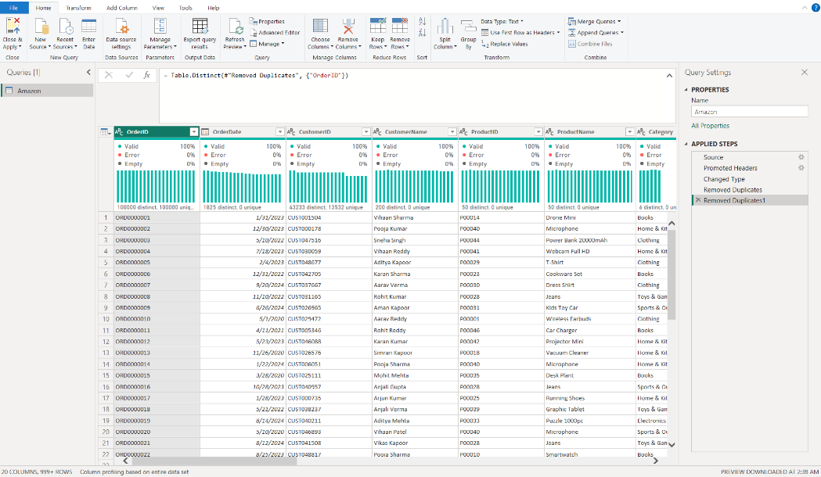
03_duplicates_removed.png

This screenshot documents the duplicate-removal stage.

Step 4: Handle Null Values
Inspect the columns for null or blank values.
Appropriate Power Query transformations are applied to handle missing information without introducing incorrect values into the dataset.
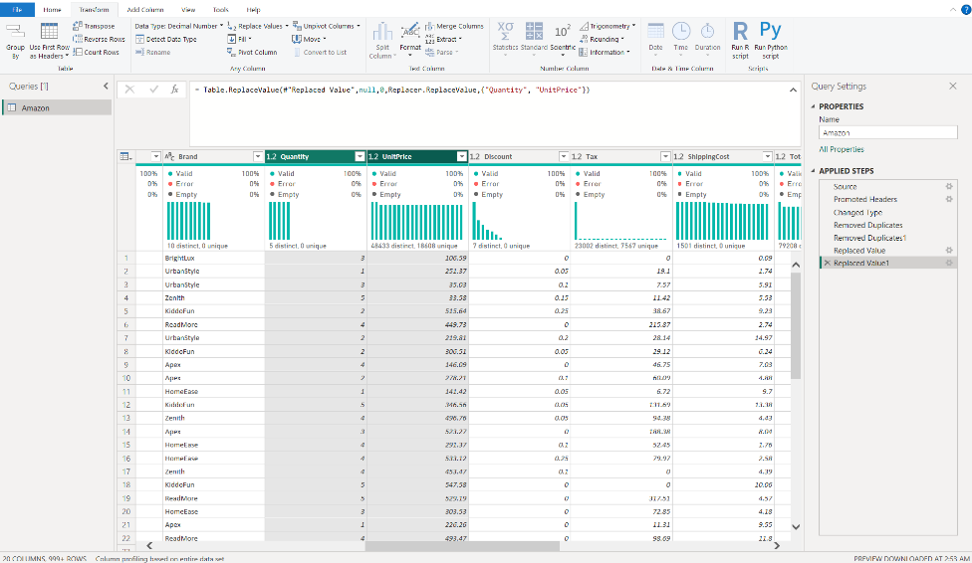
04_null_handling.png

This screenshot documents the null-value handling process.

Step 5: Correct Data Types
The important columns are assigned appropriate data types.
Column | Recommended Type
OrderDate | Date
OrderID | Text
CustomerID | Text
Quantity | Whole Number
UnitPrice | Decimal / Currency
Revenue | Decimal / Currency
OrderStatus | Text
Category | Text
Correct data types are essential for accurate calculations and visualizations.
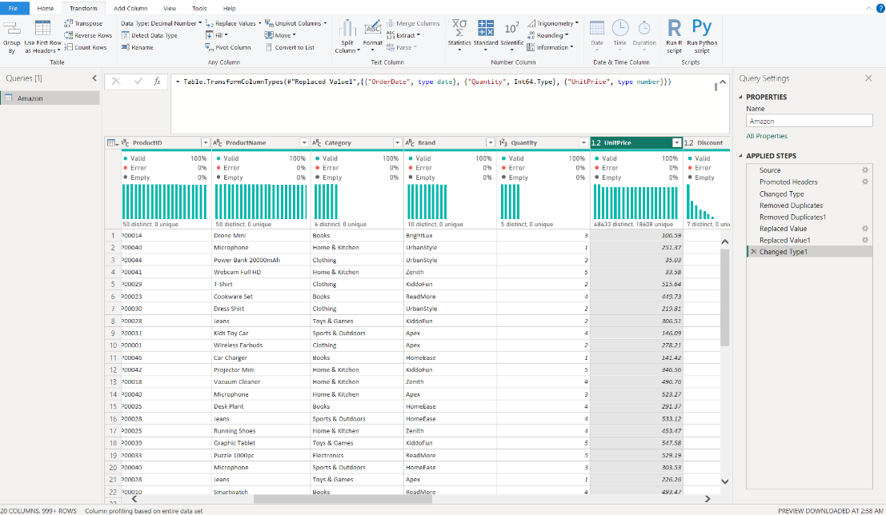
05_data_types.png

This screenshot shows the corrected data types.

PART C: CREATE CALCULATED COLUMNS
Step 6: Create Order Month
A month column is created from OrderDate.
Date.MonthName([OrderDate])
This allows monthly analysis to be performed.

Step 7: Create Order Year
Date.Year([OrderDate])
This allows yearly sales analysis.

Step 8: Create Month Year
Date.MonthName([OrderDate]) &
" " &
Number.ToText(Date.Year([OrderDate]))
This field is useful for displaying monthly trends.

Step 9: Create Quarter
"Q" &
Number.ToText(Date.QuarterOfYear([OrderDate]))
This allows quarterly analysis
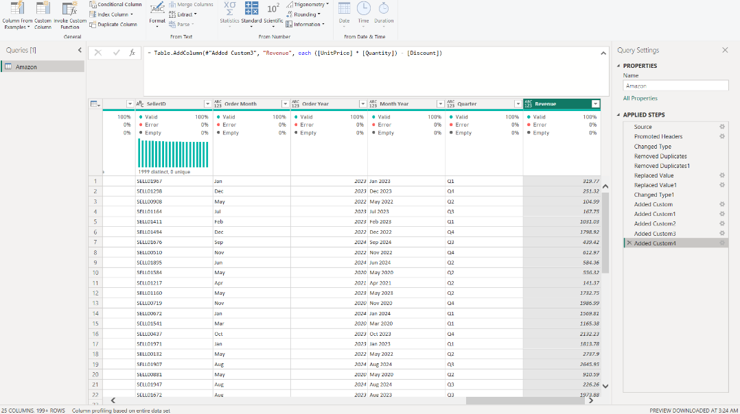
06_calculated_columns.png
Take the screenshot after creating and verifying the calculated columns.

PART D: LOAD THE TRANSFORMED DATA
Step 10: Apply Power Query Transformations
After completing the cleaning and transformation process:
- Select Close & Apply.
- Allow Power BI to load the transformed data.
- Verify that the Amazon table is available in the Data/Model view.
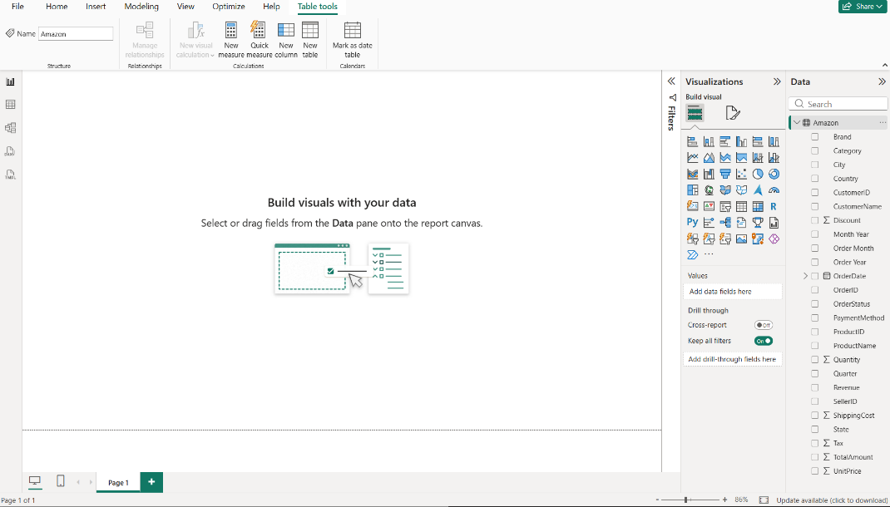
07_data_loaded.png
This screenshot documents the successful loading of the transformed data.

PART E: CREATE CALENDAR TABLE
Step 11: Create Calendar Table
A dedicated Calendar table is created to support time-based analysis.
Example DAX:
Calendar =
CALENDAR(
MIN('Amazon'[OrderDate]),
MAX('Amazon'[OrderDate])
)
The Calendar table provides a structured date dimension for the dashboard.
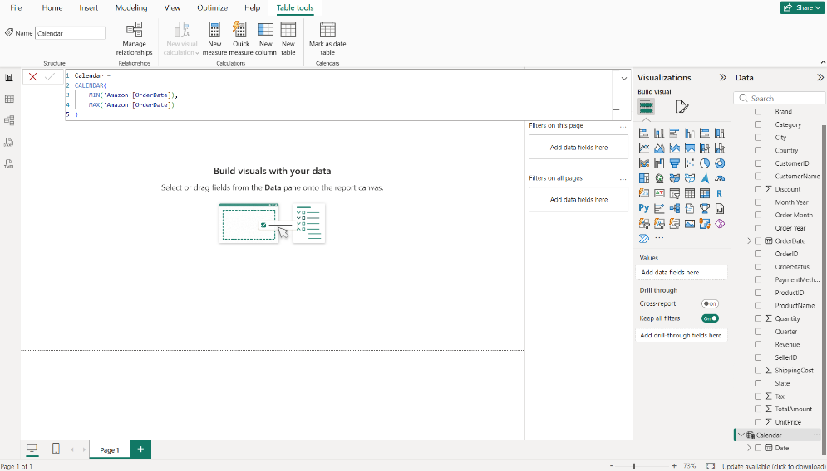
08_calendar_table.png
Take the screenshot showing the created Calendar table.

Step 12: Create Calendar Columns
The Calendar table is enhanced with additional date attributes.
Year
Year = YEAR('Calendar'[Date])
Month Number
Month Number = MONTH('Calendar'[Date])
Month Name
Month Name = FORMAT('Calendar'[Date], "MMMM")
Full Month Year
Full Month Year =
FORMAT('Calendar'[Date], "MMM YYYY")
Quarter
Quarter =
"Q" & FORMAT('Calendar'[Date], "Q")
Weekday Name
Weekday Name =
FORMAT('Calendar'[Date], "dddd")
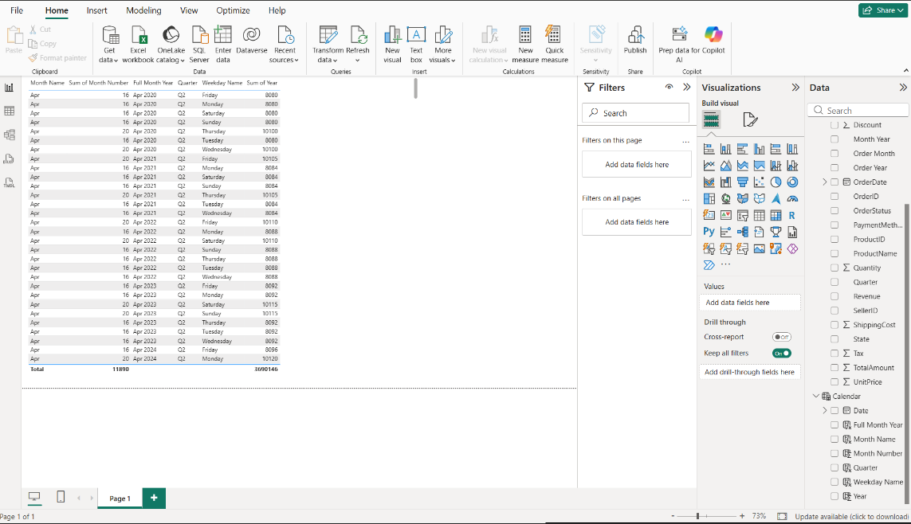
09_calendar_columns.png
This screenshot documents the Calendar table attributes.

PART F: CREATE TABLE RELATIONSHIP
Step 13: Establish Calendar Relationship
Open Model View.
Create the relationship:
Calendar[Date] → Amazon[OrderDate]
The Calendar table is used to control date-based filtering and analysis of the Amazon sales data.
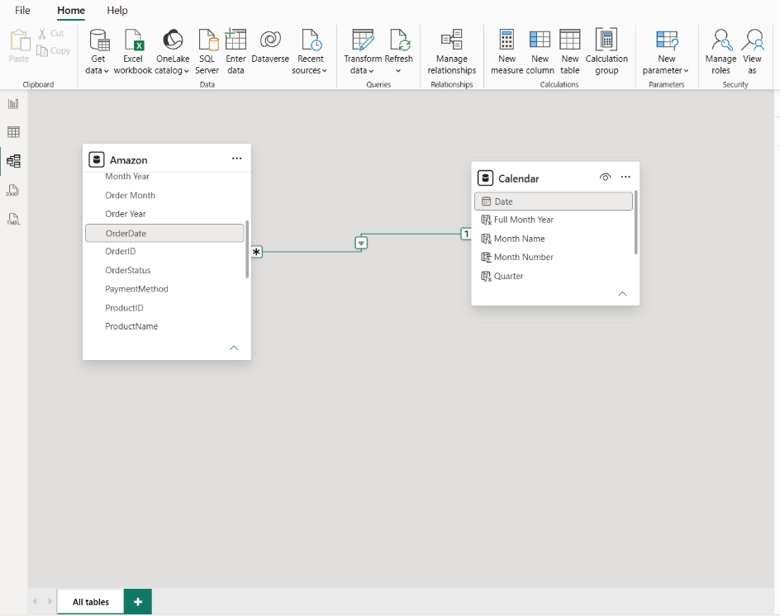
10_relationship.png
This screenshot documents the relationship between the tables.

Step 14: Mark Calendar as Date Table
Select the Calendar table and use:
Table Tools → Mark as Date Table
Select:
Calendar[Date]
This allows the Calendar table to function correctly for time-based analysis.
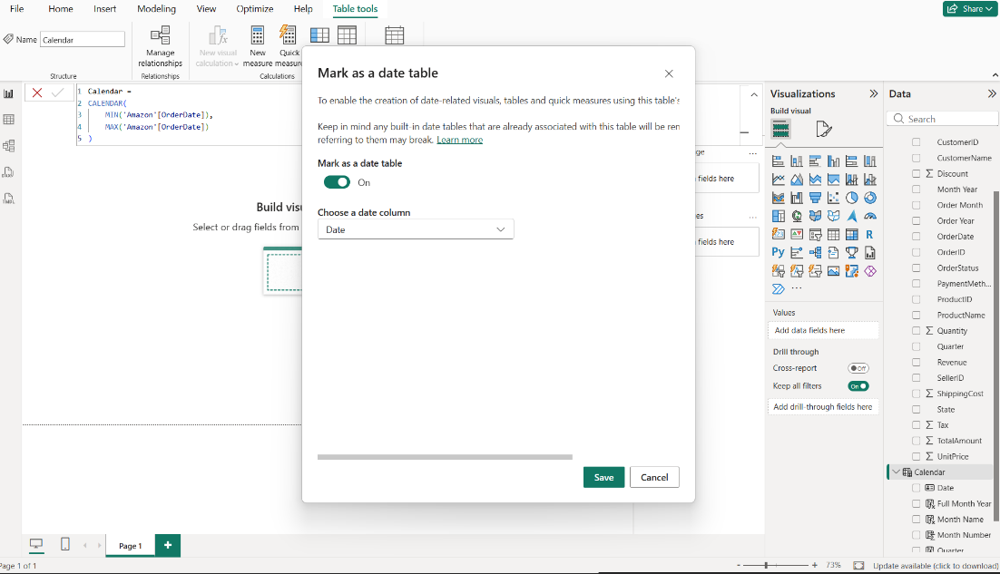
11_mark_date_table.png

PART G: CREATE DAX MEASURES
Step 15: Create Total Revenue
Total Revenue =
SUM('Amazon'[Revenue])
This measure calculates the total revenue.

Step 16: Create Total Orders
Total Orders =
DISTINCTCOUNT('Amazon'[OrderID])
This calculates the number of unique orders.

Step 17: Create AOV
AOV =
DIVIDE(
[Total Revenue],
[Total Orders]
)
AOV represents the average revenue generated per order.

Step 18: Create Unique Customers
Unique Customers =
DISTINCTCOUNT('Amazon'[CustomerID])

Step 19: Create Total Quantity
Total Quantity =
SUM('Amazon'[Quantity])

Step 20: Create Revenue per Customer
Revenue per Customer =
DIVIDE(
[Total Revenue],
[Unique Customers]
)
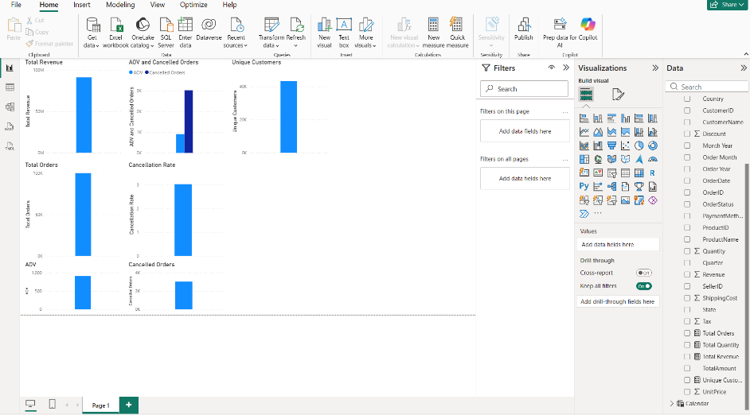
12_all_measures.png
Take the screenshot after creating and verifying the DAX measures.

PART H: BUILD KPI CARDS
Step 21: Create Total Revenue Card
Insert a Card visual.
Add:
Total Revenue
Format the card professionally using the dashboard theme.
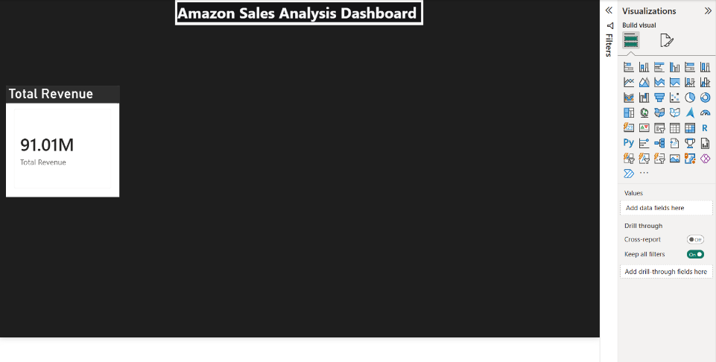
13_revenue_card.png
This screenshot documents the first KPI card.

Step 22: Create KPI Card Row
Create additional KPI cards for:
- Total Revenue
- Total Orders
- AOV
- Unique Customers
Arrange them horizontally at the top of the dashboard.
The cards provide a quick executive summary of the sales performance.
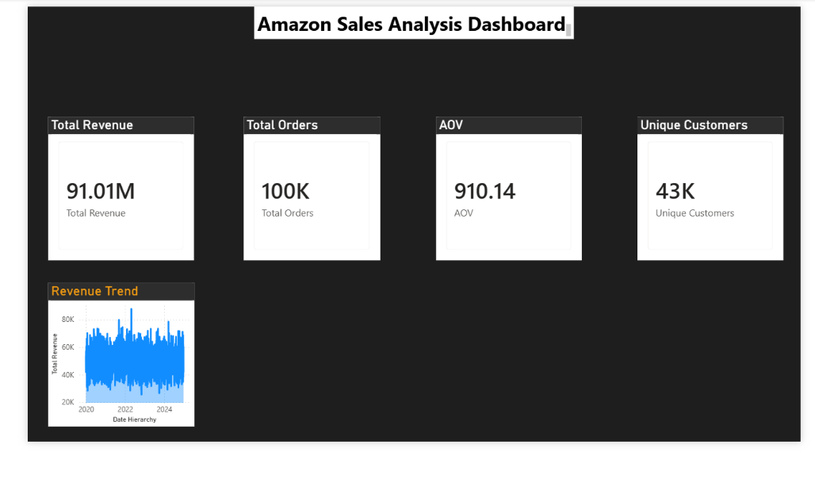
14_all_cards.png
This screenshot shows all KPI cards together.

PART I: REVENUE TREND ANALYSIS
Step 23: Create Revenue Trend
Insert a line/area chart.
Configure:
Axis:
Calendar[Full Month Year]
Values:
Total Revenue
Use the title:
Revenue Trend
The chart provides a visual representation of revenue movement over time.
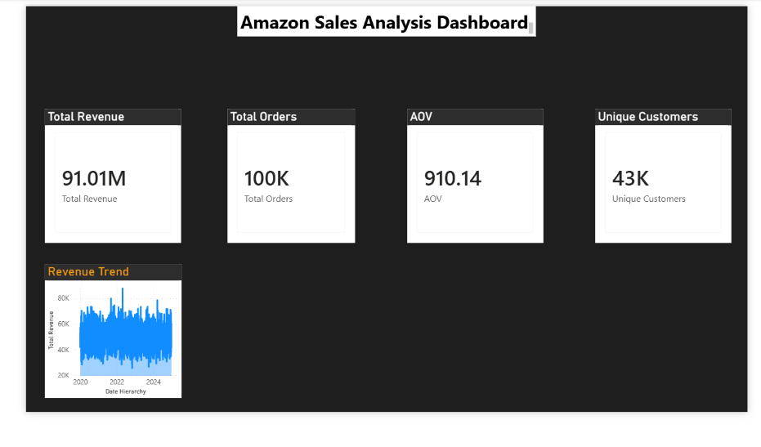
_revenue_trend.png
This screenshot documents the Revenue Trend visualization.

PART J: CATEGORY ANALYSIS
Step 24: Create Revenue by Category
Insert a bar chart.
Configure:
Axis:
Amazon[Category]
Values:
Total Revenue
Sort the visual according to revenue to make category comparison easier.
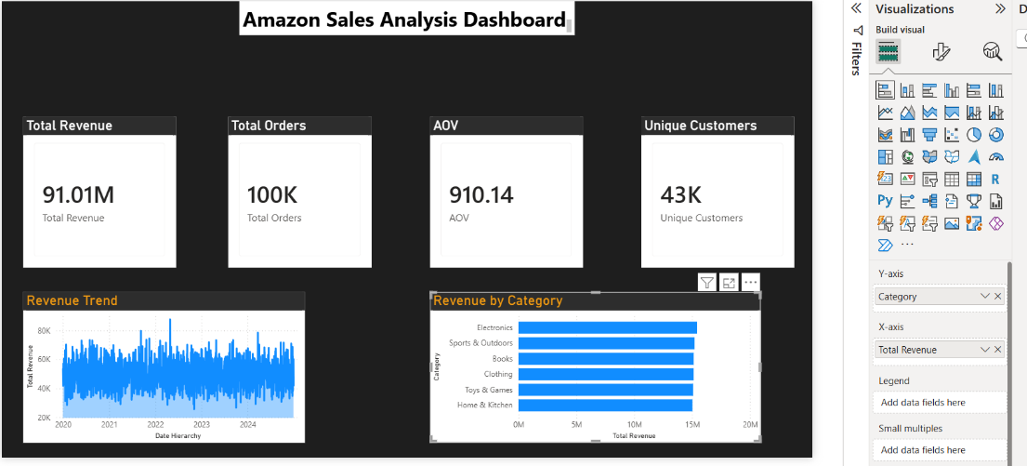
16_category_chart.png
This screenshot documents the category-level revenue analysis.

PART K: EXECUTIVE OVERVIEW
Step 25: Create Executive Overview Page
Create the main dashboard page containing a high-level summary of the business.
The page includes:
- Dashboard title
- KPI cards
- Revenue trend
- Category analysis
- Product analysis
- Supporting charts
- Navigation buttons
The purpose of this page is to allow the user to understand the overall sales performance quickly.
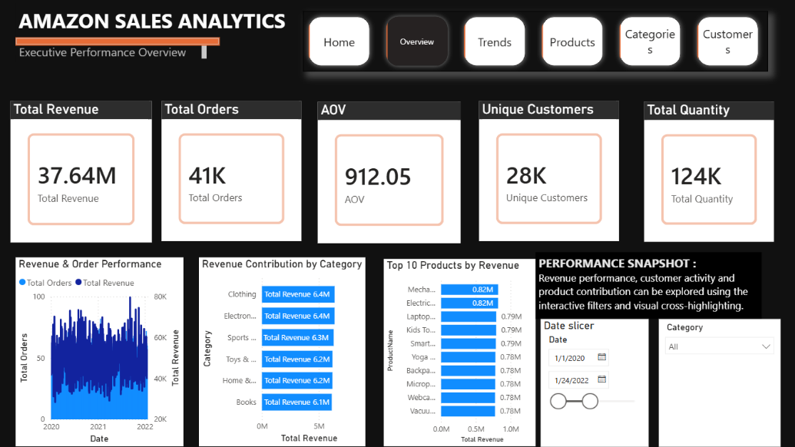
17_executive_overview.png
This screenshot shows the completed Executive Overview dashboard.

PART L: SALES TRENDS PAGE
Step 26: Create Sales Trends Page
Create a dedicated page for time-based analysis.
Include:
- Revenue trend
- Order trend
- Monthly analysis
- Category filtering
- Time-based comparisons
The page allows the user to investigate how sales performance changes over time.
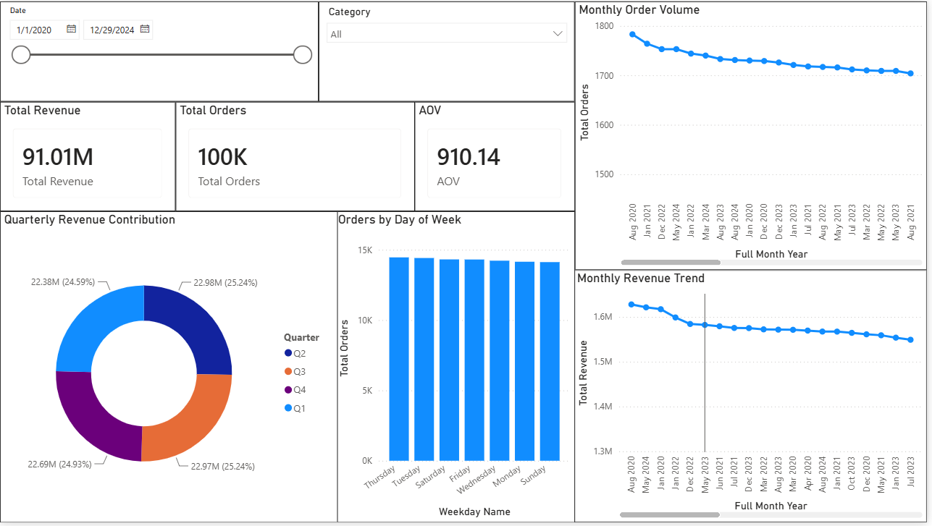
18_sales_trends.png

PART M: PRODUCT PERFORMANCE
Step 27: Create Product Performance Page
Create a product-level analytical page.
Use available product-related fields to analyze:
- Product revenue
- Product orders
- Quantity
- Product contribution
- Top-performing products
The screenshot shows product-level visualizations and comparisons.
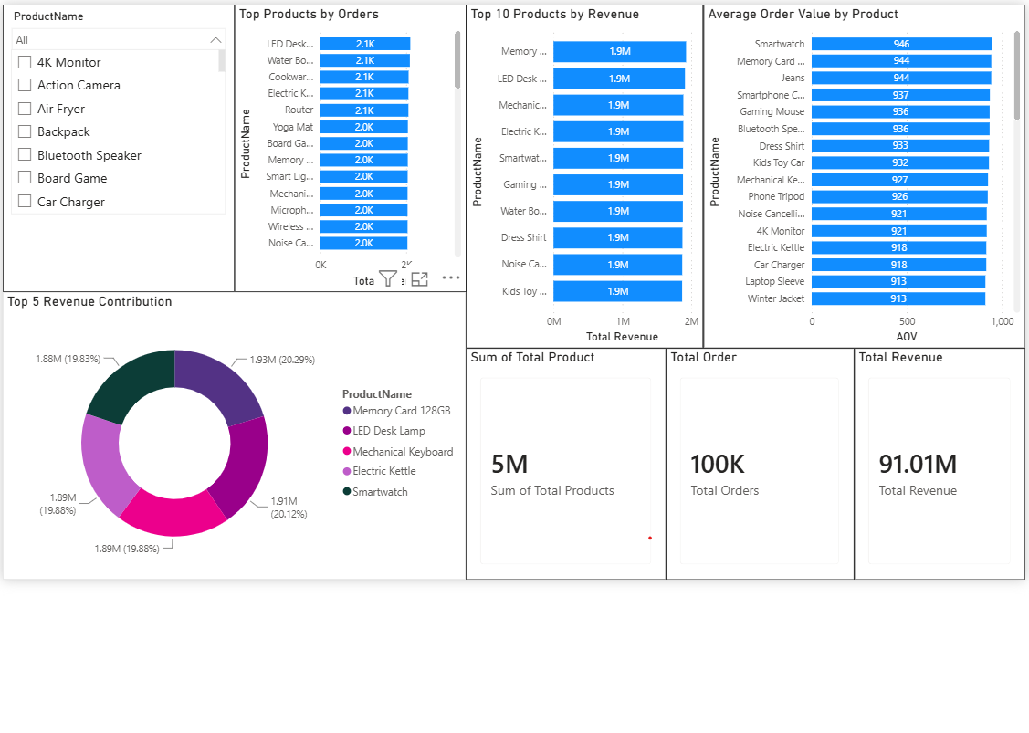
19-product_performance.png

PART N: REVENUE DEEP DIVE
Step 28: Create Revenue Deep Dive Page
The Revenue Deep Dive page provides more detailed analysis of the revenue generated by the business.
The page can combine:
- Revenue KPIs
- Revenue trend
- Category analysis
- Product analysis
- Detailed tables
- Revenue breakdowns
The purpose is to move from a high-level KPI view into detailed revenue investigation.
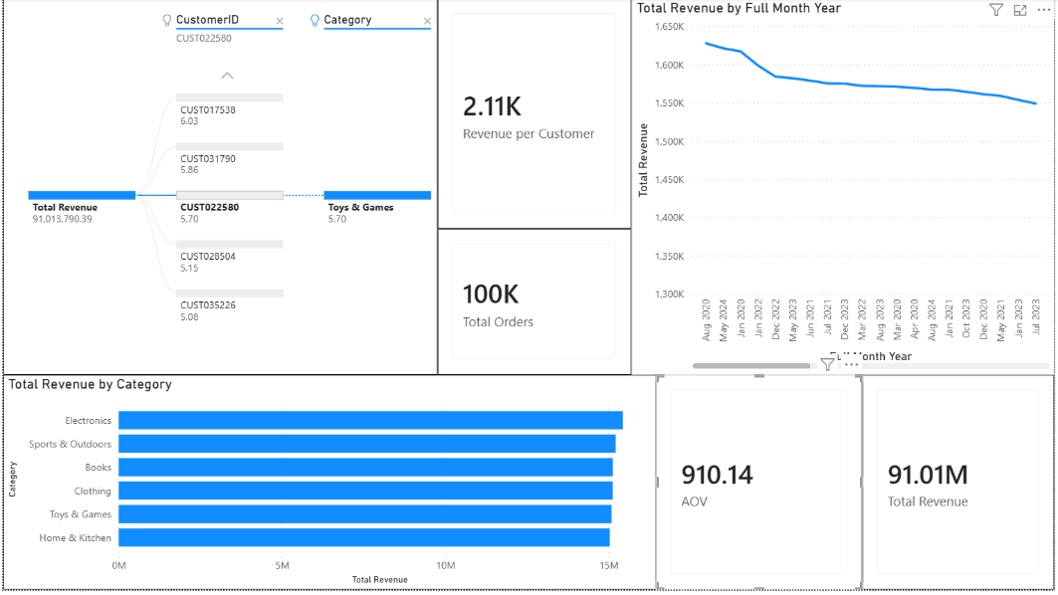
20-Revenue Deep Dive.png

PART O: PERFORMANCE INSIGHTS
Step 29: Create Performance Insights Page
Create a dedicated page to investigate important performance patterns.
The page contains analytical visuals designed to help identify:
- Revenue patterns
- Product performance
- Category performance
- Changes in performance over time
This page is intended for deeper analysis rather than only displaying basic KPIs.
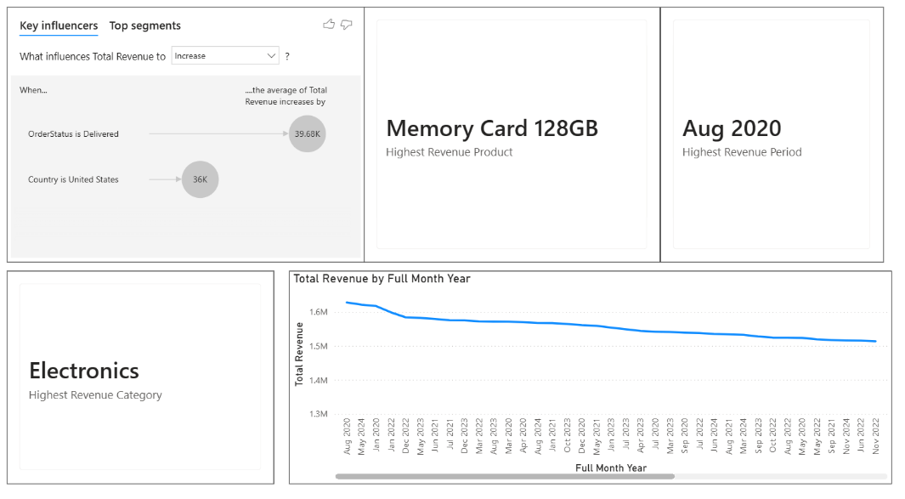
21-Performance Insights.png

PART P: EXECUTIVE INSIGHTS
Step 30: Create Executive Insights Page
Create a page that combines important findings from the dashboard.
Include:
- KPI summary
- Revenue analysis
- Category comparison
- Product analysis
- Trend information
The objective is to present the most important analytical information in a concise executive-oriented format.
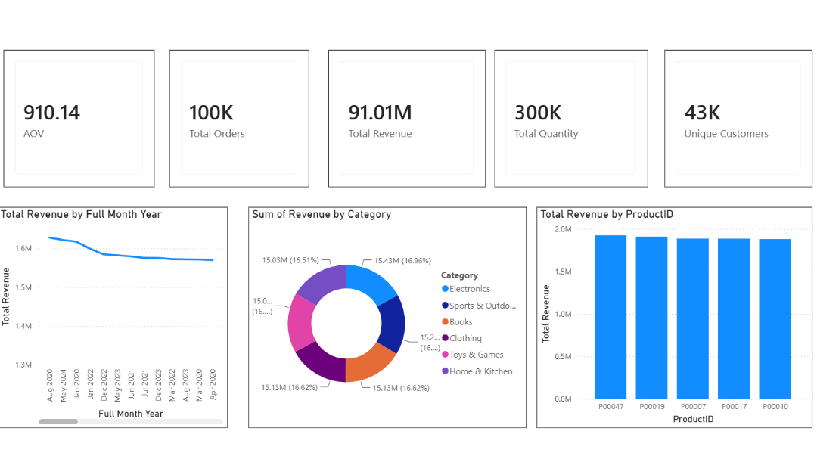
22-Executive Insights.png

PART Q: GEOGRAPHIC ANALYSIS
Step 31: Create Geographic Analysis
If geographic fields are available in the dataset, create geographical visualizations based on fields such as:
- Country
- State
- City
- Region
Analyze revenue and sales distribution geographically.
The dashboard screenshot contains a geographic/map-based analysis together with supporting charts.
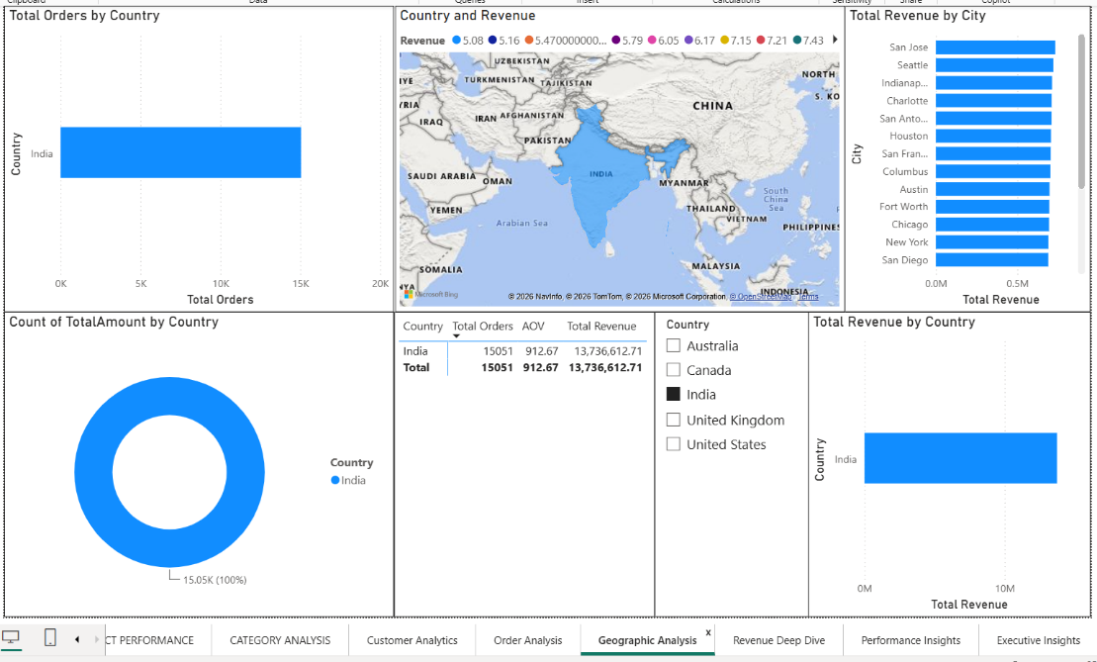
23-Geographic Analysis.png

PART R: DETAILED PRODUCT PERFORMANCE
Step 32: Create Product Performance Analysis
Create a more detailed product-performance page.
Analyze:
- Revenue by product
- Quantity by product
- Orders by product
- Product contribution
Use sorting and filtering to make comparison easier.
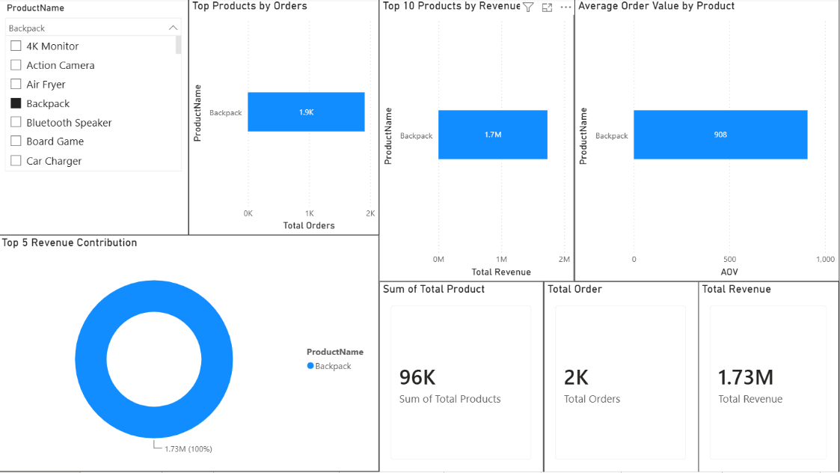
24-PRODUCT PERFORMANCE.png

PART S: CATEGORY ANALYSIS
Step 33: Create Category Analysis Page
Create a dedicated category dashboard.
Analyze:
- Revenue by category
- Quantity by category
- Orders by category
- Category contribution
- Category comparisons
Use charts and tables together where appropriate.
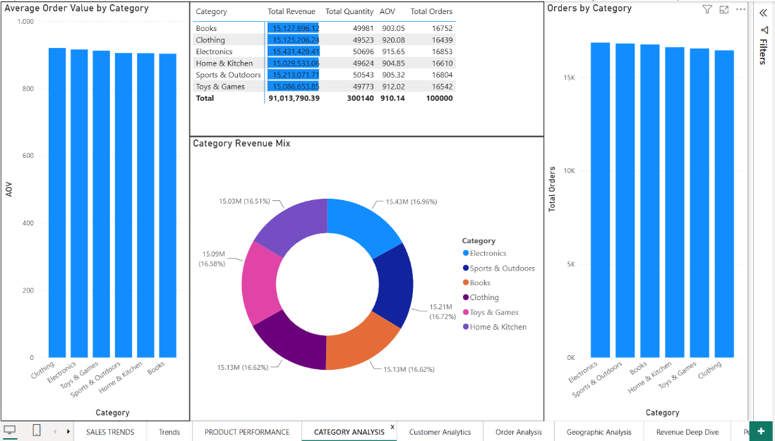
25-CATEGORY ANALYSIS.png

PART T: CUSTOMER ANALYTICS
Step 34: Create Customer Analytics Page
Create a customer-oriented dashboard.
Use:
CustomerID
to analyze:
- Number of unique customers
- Revenue by customer
- Customer contribution
- Orders by customer
A ranking or Top-N analysis can be used to identify high-revenue customers.
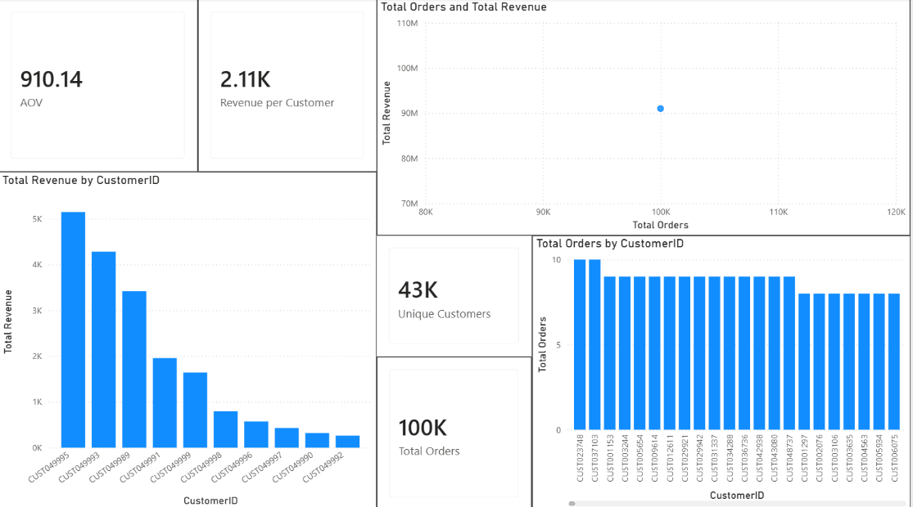
26-Customer Analytics.png

PART U: ORDER ANALYSIS
Step 35: Create Order Analysis Page
Create an order-focused analytical page.
Use:
OrderID
and:
OrderStatus
to analyze:
- Number of orders
- Order status
- Revenue by order status
- Order distribution
- Order-related trends
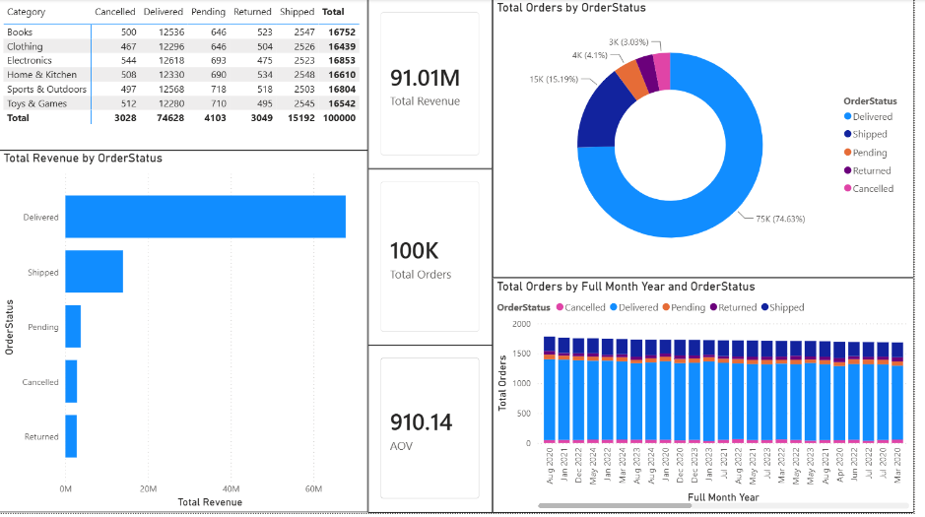
27-Order Analysis.png

PART V: TOP 10 PRODUCT ANALYSIS
Step 36: Apply Top-10 Product Filter
Create a visual showing the highest-performing products based on revenue.
Select the relevant product visual and apply:
Filters → Top N → Top 10 → By Total Revenue
This allows the dashboard to focus on the products contributing the highest revenue.
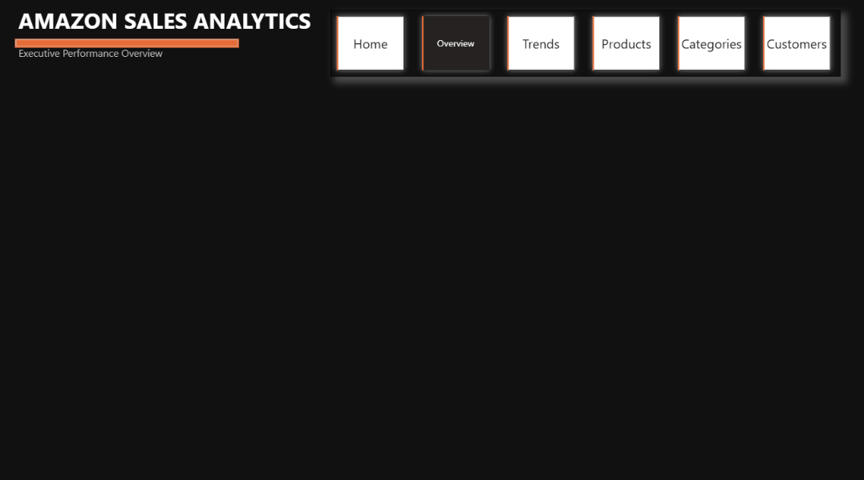
28 — Filtering TOP 10 product By Revenue
Take the screenshot showing the Top-N filtering process or resulting filtered visual.

PART W: BUTTON NAVIGATOR
Step 37: Create Page Navigation
To improve dashboard usability, create a navigation system.
Go to:
Insert → Buttons → Navigator → Page Navigator
Position the navigation buttons at the top of the dashboard.
The navigator allows users to move between the analytical pages without manually selecting page tabs.
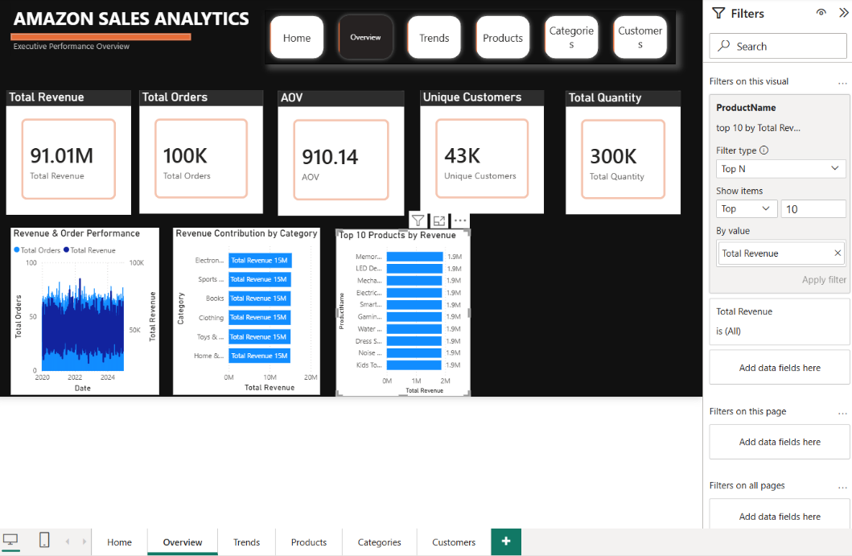
29 — Button Navigator.png
The screenshot documents the navigation system.

PART X: FULL OVERVIEW PAGE
Step 38: Review Complete Dashboard
Return to the main overview and verify the complete dashboard.
Check:
- KPI cards
- Charts
- Filters
- Navigation
- Alignment
- Titles
- Data labels
- Visual consistency
- Page layout
Ensure that the dashboard is readable and interactive.
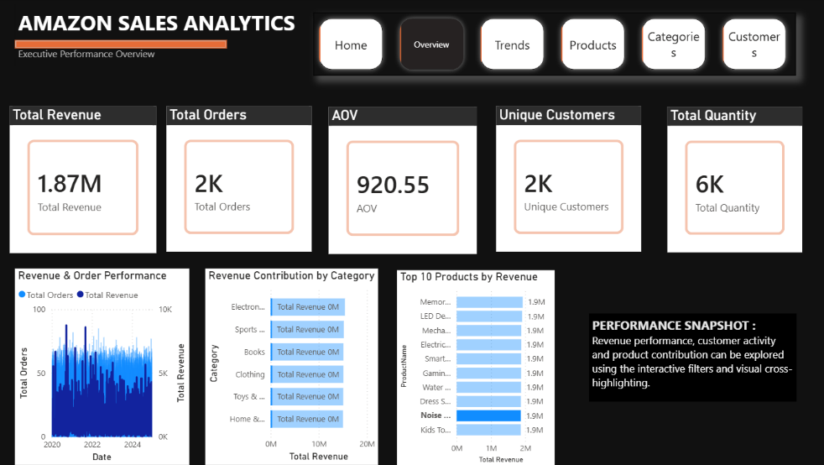
30 — Full Overview Page.png
This is the full overview screenshot.

PART Y: FINAL OVERVIEW PAGE
Step 39: Verify Final Overview
Return to the final Overview page.
The completed page should provide a concise summary of the complete Amazon sales analysis.
Verify that:
- All KPI cards display values.
- Charts respond to filters.
- Navigation works.
- Revenue analysis is visible.
- Category analysis is available.
- Product information is accessible.
- The overall design is consistent.
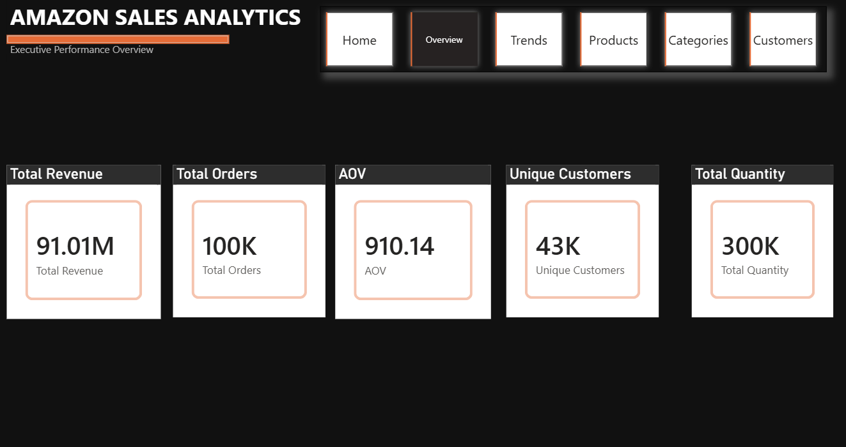
31 — Overview Page.png
This is the final overview screenshot.

7. FINAL DASHBOARD STRUCTURE
The completed project contains the following major analytical sections:
No. | Dashboard / Analysis | Main Purpose
1 | Executive Overview | Overall business performance
2 | Sales Trends | Time-based sales analysis
3 | Product Performance | Product-level analysis
4 | Revenue Deep Dive | Detailed revenue investigation
5 | Performance Insights | Performance patterns
6 | Executive Insights | Summary-level insights
7 | Geographic Analysis | Geographic performance
8 | Product Performance | Detailed product analysis
9 | Category Analysis | Category comparison
10 | Customer Analytics | Customer-level analysis
11 | Order Analysis | Order and status analysis

8. SCREENSHOT–PROCEDURE MAPPING
Screenshot | Procedure
01_power_query_open.png | Opening Power Query
02_data_quality.png | Data quality inspection
03_duplicates_removed.png | Duplicate removal
04_null_handling.png | Null-value handling
05_data_types.png | Data-type correction
06_calculated_columns.png | Calculated columns
07_data_loaded.png | Loading transformed data
08_calendar_table.png | Calendar creation
09_calendar_columns.png | Calendar attributes
10_relationship.png | Table relationship
11_mark_date_table.png | Mark Calendar as Date Table
12_all_measures.png | DAX measures
13_revenue_card.png | Total Revenue KPI
14_all_cards.png | KPI card group
15_revenue_trend.png | Revenue trend
16_category_chart.png | Category revenue
17_executive_overview.png | Executive Overview
18_sales_trends.png | Sales Trends
19-product_performance.png | Product Performance
20-Revenue Deep Dive.png | Revenue Deep Dive
21-Performance Insights.png | Performance Insights
22-Executive Insights.png | Executive Insights
23-Geographic Analysis.png | Geographic Analysis
24-PRODUCT PERFORMANCE.png | Detailed Product Performance
25-CATEGORY ANALYSIS.png | Category Analysis
26-Customer Analytics.png | Customer Analytics
27-Order Analysis.png | Order Analysis
Filtering TOP 10 product By Revenue | Top-10 product filtering
Button Navigator.png | Interactive page navigation
Full Overview Page.png | Complete report overview
Overview Page.png | Final dashboard overview

9. RESULT
The Amazon Sales Analysis project was successfully implemented using Microsoft Power BI.
The raw Amazon sales dataset was imported into Power BI and prepared using Power Query. Data quality was examined, duplicate records were removed, null values were handled, and appropriate data types were assigned.
Calculated columns were created to support date-based analysis, followed by the creation of a dedicated Calendar table and its corresponding date attributes. A relationship was established between the Calendar table and the Amazon sales data.
DAX measures were then created to calculate important business KPIs such as Total Revenue, Total Orders, AOV, Unique Customers, Total Quantity, and Revenue per Customer.
The prepared data was used to develop an interactive multi-page dashboard covering:
- Executive Overview
- Sales Trends
- Product Performance
- Revenue Deep Dive
- Performance Insights
- Executive Insights
- Geographic Analysis
- Category Analysis
- Customer Analytics
- Order Analysis
- Top-10 Product Analysis
Interactive page navigation was also implemented using a Button/Page Navigator, allowing users to move efficiently between different analytical views.
Therefore, the project successfully transformed raw transactional sales data into a structured and interactive Business Intelligence dashboard for Amazon sales analysis.

10. LEARNING OUTCOMES
After completing this experiment, the following learning outcomes were achieved:
- Understood the complete Power BI Business Intelligence workflow.
- Learned how to import transactional sales data.
- Gained practical experience with Power Query.
- Learned how to inspect data quality.
- Learned how to remove duplicate records.
- Learned how to handle null values.
- Learned how to correct data types.
- Learned how to create calculated columns.
- Learned how to create a Calendar table.
- Learned how to create date attributes.
- Learned how to establish relationships between tables.
- Learned how to mark a Calendar table as a Date Table.
- Learned how to create DAX measures.
- Understood the use of KPI cards.
- Learned how to analyze revenue trends.
- Learned how to compare categories.
- Learned how to analyze product performance.
- Learned how to perform Top-10 product analysis.
- Learned how to analyze customers and orders.
- Learned how to perform geographic analysis.
- Learned how to build executive-level dashboards.
- Learned how to create interactive page navigation.
- Learned how to organize a multi-page Power BI report.
- Gained practical experience converting raw sales data into meaningful business insights.

